Chemopreventive Activity of Rosella Tea Enhanced with Cinnamon and Lemongrass Oil Vapor Against Breast Cancer Cells

Sabila Aisyah¹, Edy Cahyono^{1,*}, Nugrahaningsih WH², Dante Alighiri¹, Adrian Maulana Zaky¹, Tri Handayani¹, Bella Permatasari¹

¹Jurusan Kimia, Fakultas Matematika dan Ilmu Pengetahuan Alam, Universitas Negeri Semarang, Semarang, 50229, Indonesia
²Jurusan Biologi, Fakultas Matematika dan Ilmu Pengetahuan Alam, Universitas Negeri Semarang, Semarang, 50229, Indonesia

*Corresponding Author. Email: edkim@mail.unnes.ac.id
Telp: +62-81325020898

Abstract
Breast cancer is the most prevalent cancer among women, remains the leading cause of cancer-related mortality worldwide, underscoring the critical importance of preventive strategies. Recent studies have demonstrated the chemopreventive and therapeutic potential of Hibiscus sabdariffa L. (roselle flower), Cinnamomum burmannii (cinnamon), and Cymbopogon citratus (lemongrass). This research aims to evaluate the chemopreventive efficacy of roselle tea enriched with cinnamon and lemongrass oil vapor, formulated using a stirred boiler tank, against T47D breast cancer cells through the MTT assay. The cytotoxicity assays revealed that the roselle herbal tea, supplemented with cinnamon and lemongrass oil vapor, exhibited enhanced cytotoxic activity against T47D cells compared to roselle tea alone, as indicated by a lower IC₅₀ value. The formulation containing 5 g of cinnamon and a 15-second exposure to lemongrass oil vapor (F6) demonstrated the highest cytotoxic activity, with an IC₅₀ value of 730 μg/mL. Conversely, the negative control (F1) exhibited the lowest cytotoxic activity, with an IC₅₀ value of 2066.6 μg/mL. These findings suggest that the incorporation of cinnamon and lemongrass oils into roselle tea significantly enhances its cytotoxic effects against T47D breast cancer cells, positioning it as a promising chemopreventive agent.

Keywords: Roselle Tea, Cinnamon, Lemongrass Oil, Chemopreventive, T47D Cells.

INTRODUCTION
Cancer remains a primary cause of morbidity and mortality worldwide, constituting a formidable public health challenge. The prevalence of cancer has been exacerbated by rapid population growth and shifting lifestyles, positioning it as the second leading cause of death among non-communicable diseases globally (Ma et al., 2021). According to the International Agency for Research on Cancer (IARC), a branch of the World Health Organization (WHO), breast cancer is among the most frequently diagnosed cancers, with an incidence rate of 11.7% (Sung et al., 2021). The urgent demand for effective cancer treatment strategies has catalyzed a burgeoning interest in approaches based on natural products. Chemoprevention, which involves the use of natural or synthetic agents to prevent cancer development, aims to halt, delay, or reverse carcinogenesis, thereby presenting a promising strategy to reduce cancer incidence (Shankar et al., 2022). Natural products, particularly those derived from plants, have demonstrated significant potential in chemoprevention due to their bioactive compounds with anticarcinogenic properties (Haque et al., 2021). Roselle tea (Hibiscus sabdariffa L.), derived from the petals of the roselle flower, is one such natural ingredient investigated for its chemopreventive properties. Rich in polyphenols, flavonoids, and anthocyanins, roselle tea is recognized for its antioxidant (Bevan et al., 2023; Essiedu & Kovaleva, 2024), anti-inflammatory (Bayani et al., 2018), and anticancer activities (Yasmin et al., 2023).
Previous research has demonstrated the potential of rosella (Hibiscus sabdariffa) flowers in inhibiting the proliferation of various cancer cell lines, including breast cancer cells. Notably, a study by Kaulika & Febriansah, (2019) identified anthocyanins in rosella flower petals as promising chemopreventive agents against T47D breast cancer cells. However, the chemopreventive efficacy of rosella tea against T47D breast cancer cells remains suboptimal, necessitating further enhancement. To augment the chemopreventive activity of rosella tea, the incorporation of bioactive compounds from additional natural sources is being explored. Cinnamon (Cinnamomum burmannii) and lemongrass (Cymbopogon citratus) are renowned for their potent anticancer properties. Cinnamon, rich in cinnamaldehyde and other polyphenolic compounds, alongside lemongrass oil, abundant in citral and other terpenes, exhibit robust antioxidant, anti-inflammatory, and cytotoxic activities. These compounds have been shown to induce apoptosis, inhibit cell proliferation, and arrest the cell cycle in cancer cells (Sharma et al., 2022). This study aims to evaluate the enhanced efficacy of rosella tea combined with cinnamon and lemongrass oils in inhibiting the growth of T47D breast cancer cells compared to rosella tea alone. The findings are anticipated to provide valuable insights into the development of more effective natural-based chemopreventive agents for breast cancer.

METHOD
Ethical Concern
All in vitro cytotoxic tests in this study have been approved by the Health Research Ethics Commission of the Faculty of Medicine, Universitas Negeri Semarang, with reference number 055/KEPK/FK/KLE/2024.
Materials and Cell Lines
Rosella plants, sourced from the Rosella Tea & Coffee Garden in Central Java, Indonesia, and cinnamon from Boyolali, Indonesia, have been authenticated by biologists at the Plant Taxonomy Laboratory of Universitas Negeri Semarang, with the entry number 232/UN.37/SHP/Lab. Taksonomi Tumbuhan/XI/2023. Lemongrass oil was procured from the distillation processes conducted at Minyak Atsiri Indonesia in Tawangmangu, Indonesia. T47D cells were acquired from the Cancer Chemopreventive Research Center (CCRC) at the Faculty of Medicine, FK-KMK, Universitas Gadjah Mada, Indonesia.

Identification of Active Compound
The chemical constituents of cinnamon and lemongrass oils were elucidated through gas chromatography-mass spectrometry (GC-MS) analysis by chemists at the Chemical Research Laboratory, Semarang State University. Concurrently, the phytochemical profile of rosella flowers was evaluated, screening for the presence of alkaloids, flavonoids, saponins, tannins, and triterpenoids. The extraction of rosella flowers for the phytochemical screening was performed using the infusion method. Specifically, 40 grams of rosella flowers were immersed in 400 mL of distilled water, followed by heating the mixture on a hotplate at 100°C for 20 minutes. After allowing the mixture to cool, it was filtered using filter paper (Nguyen & Chuyen, 2020). The resulting infusion filtrate was subsequently evaporated using a water bath to yield a concentrated extract.

Tea Formulations
Following initial testing, the ingredients underwent preparation for formulation. Rosella flowers were meticulously washed and their petals carefully selected before being subjected to drying in an oven at 40°C for 6 hours. Concurrently, cinnamon bark underwent drying and subsequent grinding to yield cinnamon powder. The processed ingredients were then formulated and processed in a stirred broiler tank. The evaporation tube containing kitchen lemongrass oil was heated to a temperature of 70°C, maintaining a steam pressure of 2 bar. The automatic stirring tube, initially containing 125 grams of rosella tea and cinnamon powder, was subjected to continuous stirring at a fixed speed of 20 rpm for 15 minutes, followed by infusion with lemongrass oil vapor. Variations in the quantity of cinnamon used and the duration of kitchen lemongrass oil evaporation are detailed in Table 1.

Table 1. Variation of Roselle Herbal Tea Formulation
Formulation | Evaporation time of lemongrass oil (s) | Weight of cinnamon powder (g)
F1 | 0 | 0
F2 | 0 | 15
F3 | 5 | 10
F4 | 5 | 15
F5 | 10 | 10
F6 | 15 | 5
Cell Line Culture
T47D cells were cultured at the Parasitology Laboratory, FK-KMK, Universitas Gadjah Mada, located in Yogyakarta, Central Java, Indonesia. The cells were maintained in Roswell Park Memorial Institute (RPMI) medium (Gibco, USA), supplemented with 10% (v/v) Fetal Bovine Serum (FBS) and 1% (v/v) penicillin-streptomycin (Gibco, USA). The cultures were incubated at 37°C in a 5% CO₂ atmosphere.
Cytotoxic Assay
The cytotoxicity of rosella tea against T47D cancer cells was evaluated using the MTT assay, following established protocols CCRC, (2009, 2012). T47D cells were cultured to 80% confluence in a CO₂ incubator, then detached using trypsin-EDTA (0.25%) and subsequently resuspended in RPMI media. After cell counting using a hemacytometer, cells were seeded at 1×10⁴ cells per well in a 96-well microplate, except for the media control well, and incubated for 24 hours. A test sample (20 mg) was dissolved in 200 µL DMSO and added to the wells in concentration series (1000, 500, 250, 125, 62.5 µg/mL) in triplicate, with rosella flowers serving as the negative control. After 24 hours of incubation, cell viability was assessed using the MTT assay. Briefly, MTT reagent (100 µL) was added to each well and incubated for 4 hours, followed by addition of 10% SDS in 0.01 N HCl (100 µL) to solubilize formazan crystals. The plate was then wrapped in foil and incubated overnight at room temperature in the dark. Absorbance readings were performed at 559 nm using an ELISA reader to quantify cell viability. This experimental approach adheres to standardized methods for assessing cytotoxic effects of natural compounds on cancer cell lines and ensures reliable data for further analysis and interpretation.
Water Content Analysis
The water content analysis of rosella tea was conducted following by standards specified in SNI 3836:2013, utilizing the oven drying method. Porcelain cups, labeled with specific sample codes, were heated in a Memmert TV30U oven at a controlled temperature of (105 ± 2)°C for one hour to achieve thermal equilibrium. Each cup was then transferred to a desiccator and weighed to determine its initial weight (W0). A precisely measured 2 g sample was placed in the cup, and the combined weight was recorded (W1). The loaded cup was returned to the Memmert TV30U oven, where it remained open at (105 ± 2)°C for three hours. After each heating cycle, the cup was transferred to a desiccator for approximately 30 minutes to cool to ambient temperature before being reweighed until a constant weight (W2) was obtained, with a precision of ≤ 1 mg. This procedure was repeated three times to ensure the reproducibility and accuracy of the results (SNI, 2013). The water content (%) was calculated as the weight loss of the cup from its initial to its final dried state, normalized to the initial weight of the sample, and multiplied by one hundred.
Total Ash Content Analysis
The ash content analysis was conducted according to SNI 3836:2013 using the thermogravimetric method. Initially, the porcelain ash cup was heated in a Memmert TV30U oven at (105 ± 2)°C for approximately one hour, followed by equilibration in a desiccator until reaching ambient temperature. The initial weight of the empty porcelain cup (W0) was recorded, and subsequently, 2 g of the sample was placed in the cup and weighed (W1). The cup containing the sample was then subjected to heating in a Nabertherm N3/R furnace at (525 ± 25)°C until complete ashing occurred, indicated by the formation of white ash. Post-ashing, the cup was allowed to cool in a desiccator to room temperature and reweighed (W2). This procedure was repeated three times in accordance with the specifications outlined in SNI 3836:2013. The ash content was determined by subtracting the weight of the empty porcelain cup (W0) from the final weight (W2), dividing by the weight of the sample (W1), and multiplying by one hundred to obtain the percentage ash content.
GC-MS Analysis
GC-MS analysis was performed on the tea sample exhibiting the highest cytotoxic activity. One gram of tea was extracted using 150 mL of boiling water, undergoing a 30-minute extraction period with initial agitation for 5 minutes. Following extraction, the tea was filtered and transferred to a separatory funnel. Subsequently, 10 mL of n-hexane was added to the separatory funnel and vigorously shaken until phase separation occurred, yielding distinct aqueous and n-hexane phases. The aqueous phase was decanted, leaving the n-hexane phase, which was then transferred to a vial and subjected to solvent evaporation at ambient temperature (Noraida et al., 2021). The resulting dried extract was subsequently analyzed using a GC-MS QP2010 instrument at the Organic Chemistry Laboratory of Universitas Negeri Semarang.

RESULTS
Determination of Compounds in Materials
The analysis of volatile components in lemongrass essential oil revealed fourteen distinct compounds, with (E)-Citral constituting the majority at 50.15% and (Z)-Citral at 33.58%. Conversely, cinnamon powder predominantly contains cinnamaldehyde (1.76%). Phytochemical analysis of rosella flower petal water extract indicated the presence of flavonoids, tannins, and triterpenoids, while alkaloids and saponins were absent. These findings corroborate previous reports documenting the phytochemical profile of rosella extracts, which similarly identified flavonoids, tannins, and triterpenoids (Sari & Aryantini, 2018).
Tea Formulations
Combining rosella tea and cinnamon powder, followed by the addition of lemongrass oil, induces a notable darkening in the color of the rosella tea (Figure 1) and imparts a distinct lemongrass aroma, indicative of thorough blending of the ingredients. The incorporation of cinnamon powder, known for its natural pigments such as coumarin and tannin, significantly influences the color transformation of rosella tea owing to the chemical characteristics inherent to cinnamon. Specifically, coumarin, a constituent of cinnamon, imparts a brown hue to the beverage, while tannin facilitates color modification through oxidative reactions with compounds present in rosella tea (Arismawanti et al., 2021). Additionally, lemongrass oil, containing citral compounds, intensifies the citrus aroma, thereby enhancing the overall sensory experience.
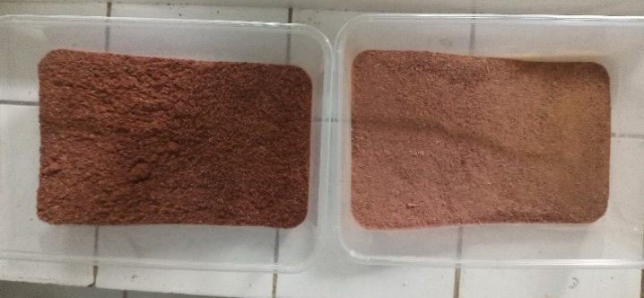
Figure 1. Physical appearance of roselle powder. Before adding cinnamon and lemongrass vapor (A), and after adding cinnamon and lemongrass vapor (B).
Cytotoxic Activity of Roselle Herbal Tea against T47D Cells
The cytotoxic activity of rosella tea, as well as rosella tea with the addition of cinnamon and lemongrass vapor against T47D cells was analyzed using the MTT method (Figure 2).

A | 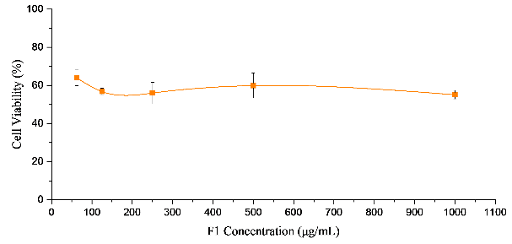 | B | 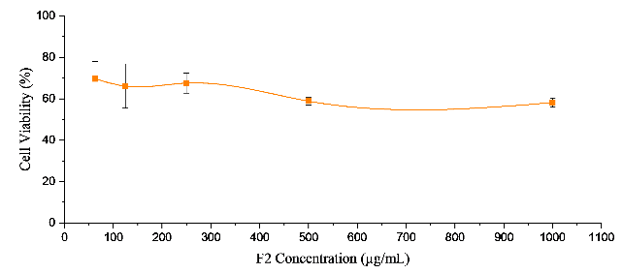
C | 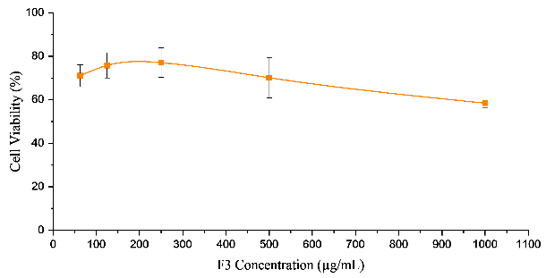 | D | 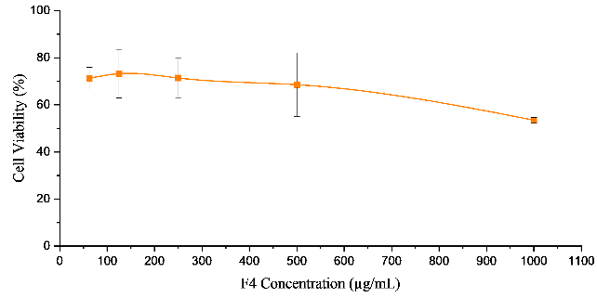
E | 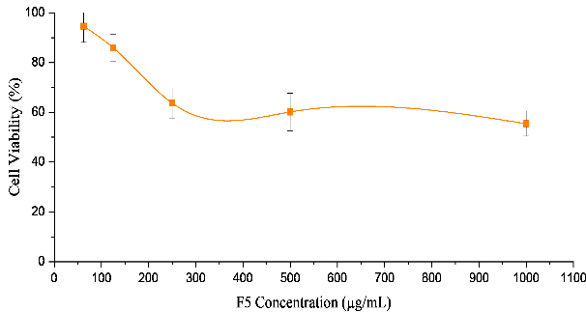 | F | 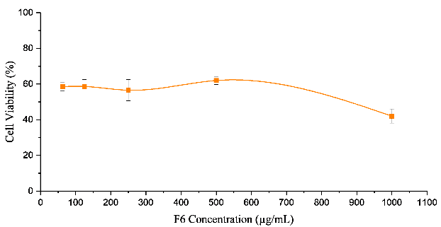
Figure 2. Cytotoxicity profile of roselle herbal tea F1 (A), F2 (B), F3 (C), F4 (D), F5 (E), F6 (F). 5x10⁴ T47D cells were seeded in each well of microplate 96-wells and treted with a concentation series of 62,5-1000 µ$μ$g/mL.

Table 2. IC₅₀ Value of Roselle Herbal Tea
Formulation | Additional Materials |  | IC₅₀ value (µ$μ$g/mL)
Formulation | Cinnamon (gram) | Lemongrass Oil Vapor (detik) | IC₅₀ value (µ$μ$g/mL)
F1 | 0 | 0 | 2.066,6
F2 | 15 | 0 | 1.554,62
F3 | 10 | 5 | 1.593,82
F4 | 15 | 5 | 1.260,04
F5 | 10 | 10 | 985,2
F6 | 5 | 15 | 730

The highest cytotoxic activity in rosella tea with the addition of cinnamon and lemongrass oil vapor was observed in formulation F6, which included rosella powder with the addition of 5 g of cinnamon and 15 seconds of lemongrass oil vapor, showing a moderate cytotoxic effect with an IC₅₀ value of 730 μg/mL, followed by formulation F5, namely rosella powder with the addition of 10 g of cinnamon and 10 seconds of lemongrass oil vapor, showing a moderate cytotoxic effect with an IC₅₀ value of 985.2 μg/mL. On the other hand, the negative control (F1), which included rosella powder without addition, showed a weak cytotoxic effect with an IC₅₀ value of 2066.6 μg/mL.

Water Content and Ash Total Content of Roselle Tea F6
The water content and total ash content tests were carried out on rosella tea which had the highest cytotoxic activity, namely rosella tea with the addition of 5 g of cinnamon powder and evaporation of lemongrass oil for 15 seconds (F6). The results of the water content and total ash content of rosella tea formulation F6 are presented in Table 3.

Table 3. Water content and total ash content of roselle tea F6
 | Result (%) | SNI (%)
Water Content | 13,628 | 7,00-8,00
Total Ash Content | 8,66 | 8,00
Based on the results of the analysis of the water content of rosella tea with a combination of cinnamon and lemongrass oil vapor, it is known that the tea has a water content of 13.628% and total ash content of 8,66%. This amount is much higher than the maximum water content determined by SNI 3836:2013 for dry packaged tea.

GC-MS Analysis of Roselle Tea F6
GC-MS analysis was performed on rosella tea formulations optimized for the evaluation of citral and cinnamaldehyde presence in each infusion, with the inclusion of lemongrass oil vapor and cinnamon powder. The chromatographic analysis (Figure 3) revealed substantial absorption of lemongrass, evidenced by a prominent peak of citral. Conversely, cinnamaldehyde exhibited a comparatively minor peak. Specifically, the presence of (Z)-citral and (E)-citral was quantified at 31.56% and 58.90%, respectively, whereas cinnamaldehyde constituted approximately 4% of the compound composition.

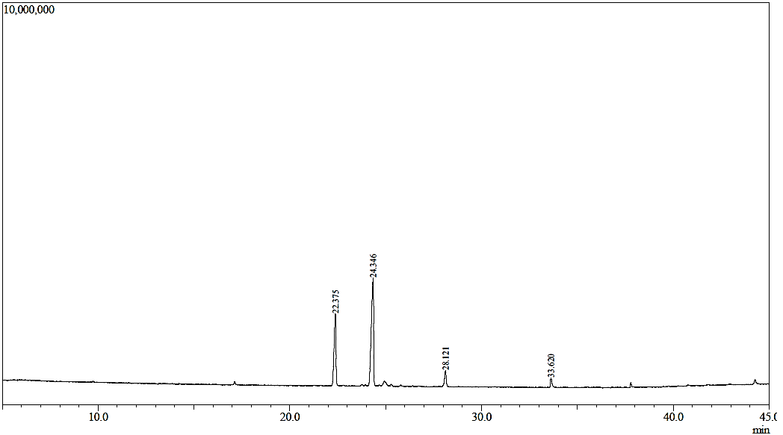
Cinnamaldehyde
(E)-Citral
(Z)-Citral
Figure 2. GC-MS chromatogram of rosella tea F6

Table 1. Peak report of roselle tea F6 compound
Puncak# | Waktu Retensi | % Area | Nama Senyawa
1 | 22.375 | 31.56 | (Z)-citral
2 | 24.346 | 58.90 | (E)-citral
3 | 28.121 | 6.35 | Nerol
4 | 33.620 | 3.20 | Cinnamaldehide

DISCUSSION
Rosella flower tea, rich in anthocyanin flavonoids, is recognized for its potential chemopreventive properties. To enhance these effects, additional natural ingredients such as cinnamon and lemongrass oil vapor are incorporated. These adjuncts feature aldehyde moieties as their primary constituents, which are well-documented for their cytotoxic effects, inducing apoptosis, necrosis, cell cycle arrest, cellular dysfunction, and reduction in tumor size (Elshafie & Camele, 2017; Sharma et al., 2022). Notably, cinnamaldehyde from cinnamon has demonstrated cytotoxicity against breast cancer cells by impeding cell proliferation, invasion, and migration, altering cytoplasmic morphology, and promoting apoptosis (Liu et al., 2020). This effect is mediated through downregulation of the antiapoptotic protein c-MYC (Yi et al., 2022), elevation of intracellular ROS via mitochondrial membrane disruption, and activation of caspase-8 (Rad et al., 2015). Meanwhile, citral, the principal bioactive constituent in lemongrass oil, significantly inhibits the proliferation of MCF-7 breast cancer cells by inducing apoptosis and reducing the ALDH-positive cell population. This action involves downregulation of β-catenin and cyclin D1 proteins, concomitant upregulation of phospho-β-catenin, and modulation of the Wnt/β-catenin pathway (Rusli et al., 2022; Thomas et al., 2016).
This study investigates the chemopreventive efficacy of rosella tea supplemented with cinnamon and lemongrass vapor against T47D breast cancer cells using the MTT assay to assess cytotoxic activity across varying ingredient concentrations. The experiment employed rosella tea as a negative control (F1) devoid of additional components. Results indicated that rosella tea alone (F1) exhibited limited cytotoxicity with an IC₅₀ value of 2,066.6 µg/mL. Conversely, incorporation of cinnamon and lemongrass vapor notably enhanced the cytotoxic potency of the herbal infusion, particularly evident in formulations F5 and F6, which demonstrated IC₅₀ values of 985.2 µg/mL and 730 µg/mL, respectively. These findings classify the F5 and F6 treatments within the moderate cytotoxicity range, suggesting potential chemopreventive capabilities, as categorized by established cytotoxicity thresholds: (1) potent cytotoxicity if IC₅₀<100 µg/mL, (2) moderate cytotoxicity if 100 µg/mL< IC₅₀<1000 µg/mL, and weak cytotoxicity if IC₅₀>1000 µg/mL following 24-hour exposure to cancer cells (Arifianti et al., 2014; Tussanti et al., 2014; Widyaningrum et al., 2020).
These outcomes underscore the promise of rosella tea combined with cinnamon and lemongrass vapor as a potential chemopreventive agent for breast cancer, aligning with previous studies Patel et al., (2015) highlighting synergistic benefits from natural compound combinations in enhancing cytotoxic efficacy against breast cancer cells. The collaborative action of cinnamon and lemongrass oil vapors within rosella flower tea appears pivotal in augmenting cytotoxic activity, promoting enhanced apoptosis induction and bolstered chemopreventive potential. Nevertheless, further investigations are imperative to elucidate the precise mechanisms through which rosella tea supplemented with cinnamon and lemongrass oil vapor inhibits T47D breast cancer cell proliferation.
CONCLUSION
Based on the conducted research, it is evident that rosella tea supplemented with cinnamon and lemongrass oil exhibits a synergistic effect, thereby demonstrating enhanced cytotoxic activity compared to the negative control consisting of plain rosella tea. Among the treatments assessed, tea subjected to F6 conditions, involving the incorporation of 5 g of cinnamon and a 15-second exposure to evaporated lemongrass oil, displayed the highest cytotoxic activity, characterized by an IC₅₀ value of 730 µg/mL, indicative of moderate cytotoxicity. These findings suggest its potential utility as a chemopreventive agent against breast cancer.
ACKNOWLEDGMENT
We extend our heartfelt gratitude to the members of the CCRC Faculty of Pharmacy at UGM for their assistance in conducting the cytotoxic test.
REFERENCES
Arifianti, L., Studiawan, H., & Megawati, L. (2014). In Vitro Test of Soursop Seed Extract (Annona muricata L.) Activity Against Mammalian Cancer Cells. Jurnal Farmasi Dan Ilmu Kefarmasian Indonesia, 1(2).
Arismawanti, P., Irmayanti, & AR, C. (2021). Formulation For Making Edible Spoon With Additional Variants of Natural Dye Extract and Cinnamon Powder (Cinamomum Burmanii) as Anti-Microbial. Serambi Journal of Agricultural Technology, 3(2), 96–105.
Bayani, G. F. El, Marpaung, N. L. E., Simorangkir, D. A. S., Sianipar, I. R., Ibrahim, N., Kartinah, N. T., Mansur, I. G., Purba, J. S., & Ilyas, E. I. I. (2018). Anti-inflammatory Effects of Hibiscus Sabdariffa Linn. on the IL-1β/IL-1ra Ratio in Plasma and Hippocampus of Overtrained Rats and Correlation with Spatial Memory. The Kobe Journal of Medical Sciences, 64(2), 73–83.
Bevan, P., Pastor, M. V., Almajano, M. P., & Codina-Torrella, I. (2023). Antioxidant and Antiradical Activities of Hibiscus sabdariffa L. Extracts Encapsulated in Calcium Alginate Spheres. Polymers, 15(7), 1–19.
CCRC. (2009). Prosedur Tetap: Perhitungan Sel. Cancer Chemoprevention Research Center Farmasi UGM Yogyakarta, 1–4.
CCRC. (2009). Prosedur Tetap Panen Sel. Cancer Chemoprevention Research Center Fakultas Farmasi UGM, 1–3.
CCRC. (2009). Prosedur Tetap Preparasi Sampel. Fakultas Farmasi UGM, 1–3.
CCRC. (2012). Uji Sitotoksik Metode MTT. Cancer Chemoprevention Research Center Fakultas Farmasi UGM, 6–9.
Elshafie, H. S., & Camele, I. (2017). An Overview of The Biological Effects of Some Mediterranean Essential Oils on Human Health. BioMed Research International, 1(1), 1–14.
Essiedu, J. A., & Kovaleva, E. G. (2024). Physicochemical, antioxidant activity, and sensory characteristics of mead produced with Hibiscus sabdariffa and Betula pendula (Birch sap). Biocatalysis and Agricultural Biotechnology, 58(April), 103189.
Haque, A., Brazeau, D., & Amin, A. R. (2021). Perspectives on natural compounds in chemoprevention and treatment of cancer: an update with new promising compounds. European Journal of Cancer, 149(1), 165–183.
Kaulika, N., & Febriansah, R. (2019). Chemopreventive Activity of Roselle’s Hexane Fraction against Breast Cancer by In-Vitro and In-Silico Study. Advances in Health Sciences Research, 15(1), 66–71.
Liu, Y., An, T., Wan, D., Yu, B., Fan, Y., & Pei, X. (2020). Targets and Mechanism Used by Cinnamaldehyde, the Main Active Ingredient in Cinnamon, in the Treatment of Breast Cancer. Frontiers in Pharmacology, 11.
Ma, L., Zhang, M., Zhao, R., Wang, D., Ma, Y., & Ai, L. (2021). Plant Natural Products : Promising Resources for. Molecules, 26(4), 933.
Nguyen, Q. V., & Chuyen, H. Van. (2020). Processing of herbal tea from roselle (Hibiscus sabdariffa L.): Effects of drying temperature and brewing conditions on total soluble solid, phenolic content, antioxidant capacity and sensory quality. Beverages, 6(1), 1–11.
Noraida, L., Bintang, M., & Priosoeryanto, B. P. (2021). N-hexane Extract and Fraction of Green Tea as Antiproliferation of MCM-B2 Breast Cancer Cells In Vitro. Current Biochemistry, 6(2), 92–105.
Patel, P. B., Thakkar, V. R., & Patel, J. S. (2015). Cellular effect of curcumin and citral combination on breast cancer cells: Induction of apoptosis and cell cycle arrest. Journal of Breast Cancer, 18(3), 225–234.
Rad, S. K., Kanthimathi, M. S., Malek, N. A., Lee, G. S., Looi, C. Y., & Wong, W. F. (2015). Cinnamomum cassia Suppresses Caspase-9 through Stimulation of AKT1 in MCF-7 Cells but Not in MDA-MB-231 Cells. PLoS One, 10(12), 1–22.
Rusli, M. E. F., Rosli, R., Ramli, U. B., Suhaimi, S. A., & Saad, N. (2022). The Potentiality of Citral in Targeting Breast Cancer Multicellular Tumour Spheroids (MTS). Malaysian Journal of Medicine and Health Sciences, 18(2), 2636–9346.
Sari, F., & Aryantini, D. (2018). Karakter Spesifik dan Pengaruh Pemberian Oral Ekstrak Terpurifikasi Kelopak Rosella (Hibiscus sabdariffa L.) terhadap Makroskopis Organ Hepar Tikus Wistar. Jurnal Wiyata, 5(1), 1–9.
Shankar, M., Swetha, M., Keerthana, C. K., Rayginia, T. P., & Anto, R. J. (2022). Cancer Chemoprevention: A Strategic Approach Using Phytochemicals. Frontiers in Pharmacology, 12(January), 1–25.
Sharma, M., Grewal, K., Jandrotia, R., Batish, D. R., Singh, H. P., & Kohli, R. K. (2022). Essential oils as anticancer agents: Potential role in malignancies, drug delivery mechanisms, and immune system enhancement. Biomedicine and Pharmacotherapy, 146(1), 1–36.
SNI. (2013). Teh Kering dalam Kemasan.
Sung, H., Ferlay, J., Siegel, R. L., Laversanne, M., Soerjomataram, I., Jemal, A., & Bray, F. (2021). Global Cancer Statistics 2020: GLOBOCAN Estimates of Incidence and Mortality Worldwide for 36 Cancers in 185 Countries. CA: A Cancer Journal for Clinicians, 71(3), 209–249.
Thomas, M. L., de Antueno, R., Coyle, K. M., Sultan, M., Cruickshank, B. M., Giacomantonio, M. A., Giacomantonio, C. A., Duncan, R., & Marcato, P. (2016). Citral reduces breast tumor growth by inhibiting the cancer stem cell marker ALDH1A3. Molecular Oncology, 10(9), 1485–1496.
Tussanti, I., Johan, A., & Kisdjamiatun. (2014). In vitro Cytotoxicity of Ethanolic Extract of Parijoto Fruit (Medinilla speciosa, reinw.ex bl.) terhadap Sel Kanker Payudara T47D. Jurnal Gizi Indonesia, 2(2), 53.
Widyaningrum, N., Hussana, A., Saeful Adi, R., Tiastuti, M., & Misti Utami, K. (2020). Cytotoxic Activity of Combination of Fig Fruit Extract and Olive Oil against Breast Cancer Cells. Jurnal Farmasi Sains Dan Praktis, 6(1), 2579–4558.
Yasmin, R., Gogoi, S., Bora, J., Chakraborty, A., Dey, S., Ghaziri, G., Bhattacharjee, S., & Singh, L. H. (2023). Novel Insight into the Cellular and Molecular Signalling Pathways on Cancer Preventing Effects of Hibiscus sabdariffa : A Review . Journal of Cancer Prevention, 28(3), 77–92.
Yi, X., Pei, T., Li, S., & Huang, L. (2022). Cinnamic aldehyde induces apoptosis of breast cancer cells via STAT3/cMyc pathway. Research Square, 1(1), 1–18.

