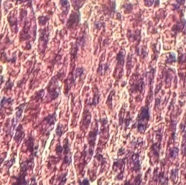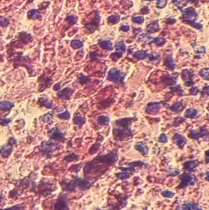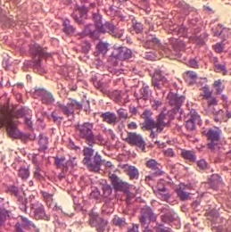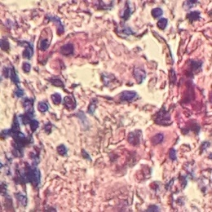
D
C
B
A
Figure 1. Picture of kidney histology of mice with 40x10 magnification. Effect of liberica coffee for 28 days with control group (A), 8,000 ppm / day (B), 10,000 ppm / day (C), and 12,000 ppm / day (D ) Normal tubular cell (A) (arrow). Picnotic cells and fat degeneration (B and C) (broken arrows). Karioreksis cells and fat degeneration (D) (broken arrows).

